*This program is coordinated by the*

*Wisconsin Institute for Healthy Aging*





Contact Amie

at

Vilas County Commission on Aging

715-479-3625 or 1-800-374-1123

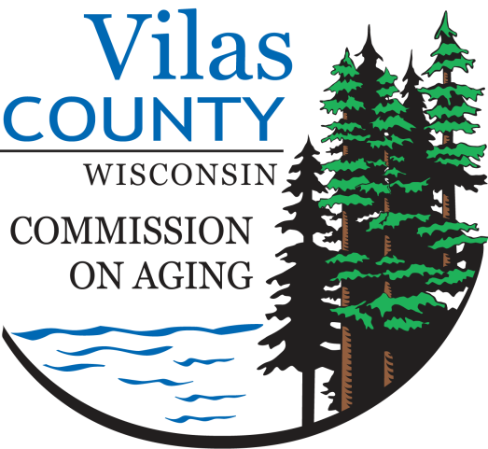



**Stepping On**

Building confidence,  
reducing falls  
  
Join this 7-week workshop where you’ll learn exercises and strategies to help prevent you from falling.

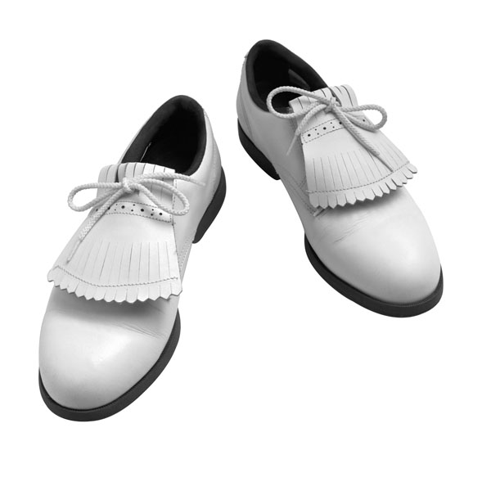

**Why Should I be Concerned   
about Falling?**

Falling is very common; it can result in injury and can shake your confidence. The threat of falling can be a barrier to safely doing all the things you want to do at home and in the community. That’s why preventing falls is critical to maintaining independence.

**Did you know?**

* More than one-third of people age 65 or older fall each year.
* Falls are the leading cause of injury and hospitalization for trauma and death among older adults.
* 35% of people who fall become less active.
* 40% of people who enter a nursing home had a fall in the prior 30 days.

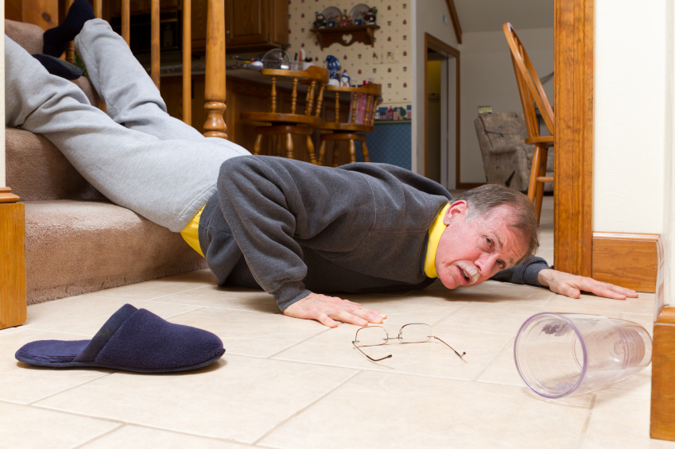



**Stepping On Class Schedule**

**Thursday Starting**

**April 13-May 25 2017**

**1:00-3:00 p.m.**

**At**

**Prince of Peace Lutheran Church**

**5030 Hwy 70 West**

**Eagle River, WI 54521**

**Registration Information**

**Contact Amie**

**At**

**Vilas County Commission on Aging**

**715-479-3625 or**

**800-374-1123**

**Space is limited**

**Cost: $10 which includes all materials and healthy snacks**

**What is Stepping On?**

Stepping On is a program that has been researched and proven to reduce falls in older people.

It consists of a workshop that meets for two hours a week for seven weeks. Workshops are led by a health professional and a peer leader – someone who, just like you, is concerned about falls. In addition, local guest experts provide information on exercise, vision, safety, and medications.

**Topics include:**

* Simple and fun balance and strength training
* The role vision plays in keeping your balance
* How medications can contribute to falls
* Ways to keep from falling when out in your community
* What to look for in safe footwear
* How to eliminate falls hazards from your home



**Here’s what some workshop participants have to say:**

*“When I’m walking I still think, ‘lift your feet, walk heel-to-toe.’ I have stopped falling outside! It has made me more aware of the way I walk.”  
  
“Not only did* we learn some things about preventing falls, but we had a good time doing it. It was really fun.”

**Is this workshop for you?**

Stepping On is designed specifically for anyone who:

* Is 65 or older
* Has had a fall in the past year
* Is fearful of falling
* Lives at home
* Does not have dementia



