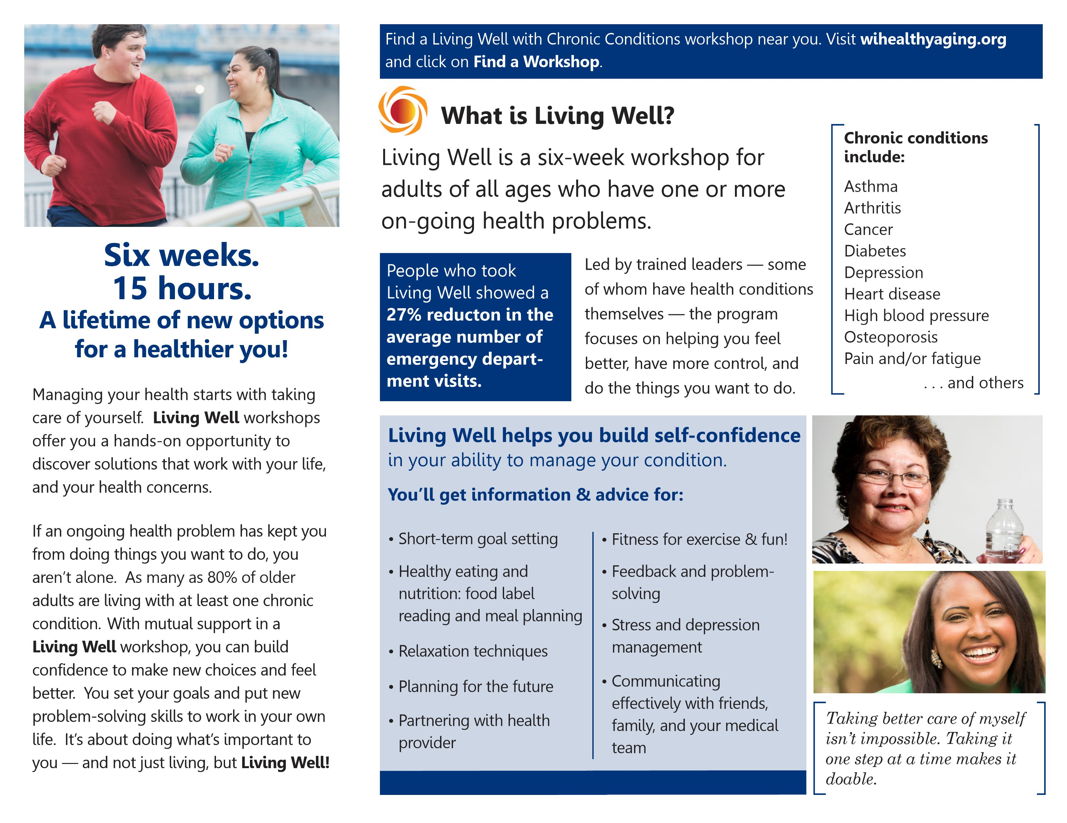



**Join Us**

**Tuesdays October 24 through November 28, 2017**

**From 1:00 -3:30 p.m.**

**At**

**Prince of Peace Lutheran Church**

**5030 Hwy 70 West**

**Eagle River, WI 54521**

**Cost: $20, which includes all materials and healthy snacks.**

**Scholarships are available**

**To Register or For More Information**

**Contact Amie at**

**Vilas County Commission on Aging**

**715-479-3625 or**

**1-800-374-1123**

**Space is limited**

