

**To Register Call:**

**Amie Rein**

**Vilas County Commission on Aging**

**715-479-3625 or**

**1-800-374-1123**

**Space is limited**



**Feel better.**

**Be in control.**

**Do the things**

**you want to do.**

**Join Us**

Tuesdays September 12- October 17, 2017

10:00 a.m. to 12:30 p.m.

Peace Lutheran Church

10868 Old Hwy 51 N

Arbor Vitae, WI

*Sponsored by*

*Vilas County Commission on Aging*

***“The workshops put me back in charge of my life, and I feel great. I only wish I had done this sooner.”***

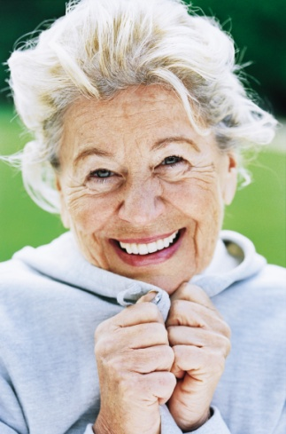

**Put Life**

**Back in**

**Your Life**

Are you an adult with an ongoing health condition?

You’ll get the support you need, find   
practical ways to deal with pain and   
fatigue, discover better nutrition and exercise choices, understand new treatment choices, and learn better ways to talk with your doctor and family about your health.

If you have conditions such as diabetes, arthritis, high blood pressure, heart disease, chronic pain, or anxiety, the ***Living Well*** Workshop can help you take charge of your life.